Version 4.0

Task 0: Explain what you are doing/ going to accomplish

Within this version I am going to set up a page for dog owners to add a new dog to the page. This will use a form which then takes them to a success page.

Task 1: Sketch interface design

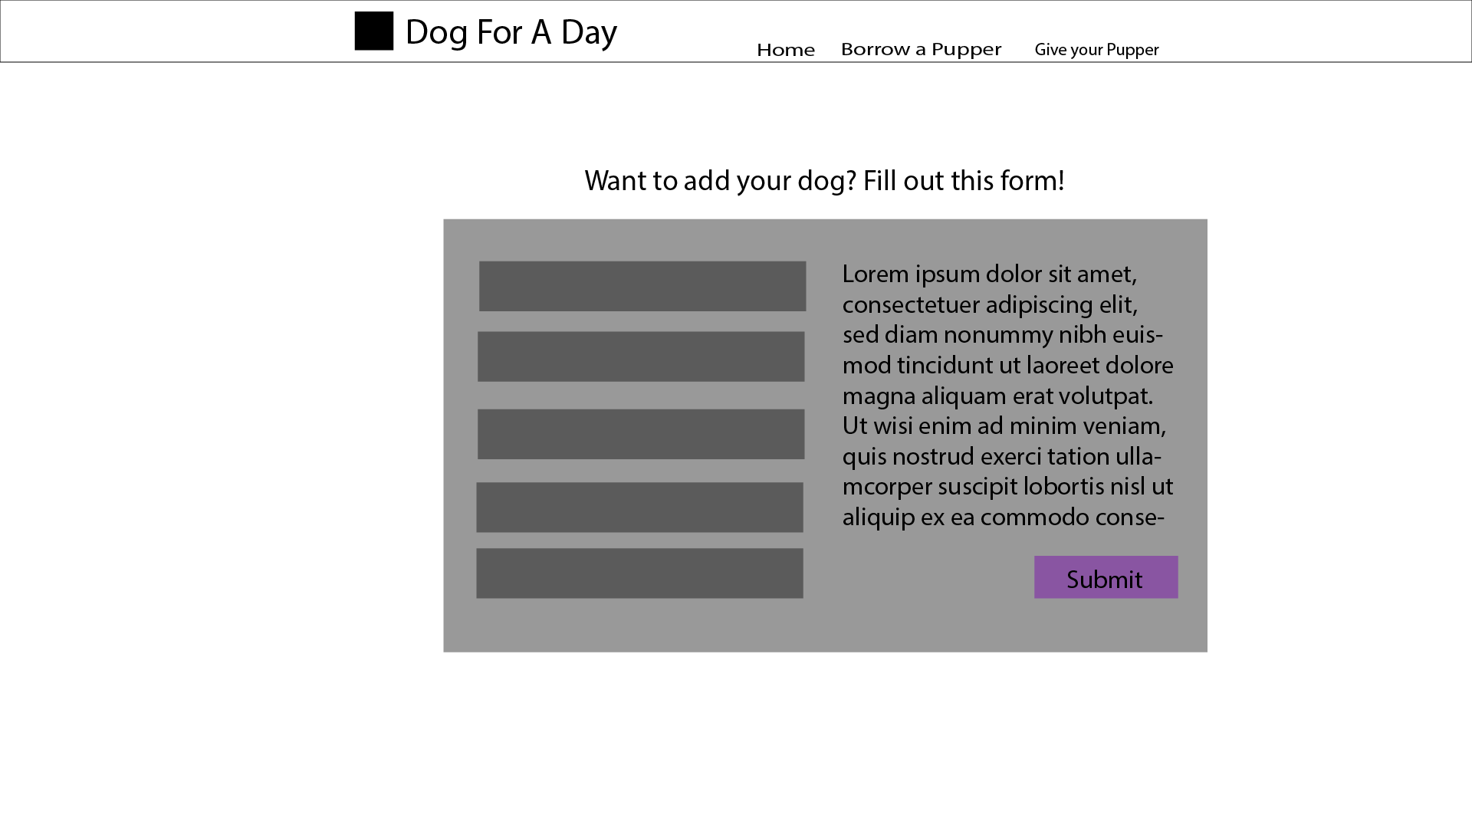

A nice clean form to be filled out by the user, this should be very basic and easy to fill out.

Task 2: Identify any classes required

Class Dog

Will need the variables, Name, Age, Description, Breed, Available, Gender

Task 3: Identify information to be displayed

This page will display the input forms for the Dog class and all of its variables in the dog_list

Task 4: Identify user inputs

The user will input all the information about their dog.

Name. age, gender, breed and friendliness

Task 5: Identify any constants or existing data if required

No constants for this version

Task 6: Identify indexed data structures

Data dictionary called dog_list is what the new dog classes will be inputted to.

Task 7: Determine what calculations are necessary

No calculations needed in this version

Task 8: Develop a modular structure for your program

Set route to (‘/new-dog-page)

Set view to (‘new-dog-page’)

Set showcase function to:

Set var data to be dictionary of dog_list

Return data to page

Set route to (‘/new-dog-action)

Set view to (‘new-dog-action’)

Set showcase function to:

Set name to be request.forms.get(“name”)

Repeat this step with each variable in the Dog class

Set new_dog to be class Dog with the parameters of all of the above defined variables

Append new_dog to dog_list

Set route to (‘/new-dog-success/<dog_id>)

Set view to (‘new-dog-success’)

Set showcase function to:

Set Dog_id equal to integer of dog.id

Set found dog to none

For dog in dog_list

If dog id is equal to dog_id

Set Found_dog to dog

Break loop

Set data to dictionary of dog

Return data to page

Task 9: Define the functions identified

New_dog_page – the page with the form to add a new dog to the list

New_Dog_Action – the action page that routes you to new_dog_success but adds the dog to the list

New_Dog_Success – the success page to show the user they have successfully added a new dog

Task 10: Address any relevant implications such as usability, functionality, legal/ethical requirements.

No copyrighted images. No illegal or explicit images etc.

The form needs to be simple to understand and fill out. Otherwise I risk the chance of confusing the user and the form being filled out incorrectly.

I will continue to use the same colour theme throughout the pages to ensure a fluid experience to keep the user happy.

Functionally, this version needs to have an easy to fill out form and successfully submit that form quick enough without any major bugs.

Task 11: Document test cases for testing the program

Test cases: Load the new-dog page and see if it shows up. Then fill out the form to ensure the correct information is sent to the website/ensure the success page comes up correctly. Finally I need to ensure that once added, the dog correctly shows up on the showcase page.

Using html features such as class=”validate” means that I will not need to use try catch errors in my python as the html form can do it itself. The validate class makes sure the input is of the correct type etc.

Task 12: Refine the plan

When adding a new dog, then going into the dogs personal page, I got the error. Dog.friendliness is not applicable. Str type.

This meant I needed to add the new dogs friendliness rating as an integer. It was as simple as adding int() around the code friendliness = int(request.forms.get(“friendliness”)

I also needed to add the code to the new-dog-action page to return the data of the dog so it could show it to the user

New PseudoCode

Set data to a dictionary of new_dog

Return data to the page

This meant that the new dog could now show up

To add the friendliness slider, I needed Javascript code to show the user the current value of the slider, this I copied from online <https://www.w3schools.com/howto/howto_js_rangeslider.asp>

It was an easy fix for a problem.

* I also realised within building the pages, that the new-dog-success page was unneeded, as it was just splitting the page up unnecessarily, So I deleted it.

Task 13: Document testing

Can I add a new dog? Does the form show up correctly? Does the dog show up on the new page?

Check error inputs.

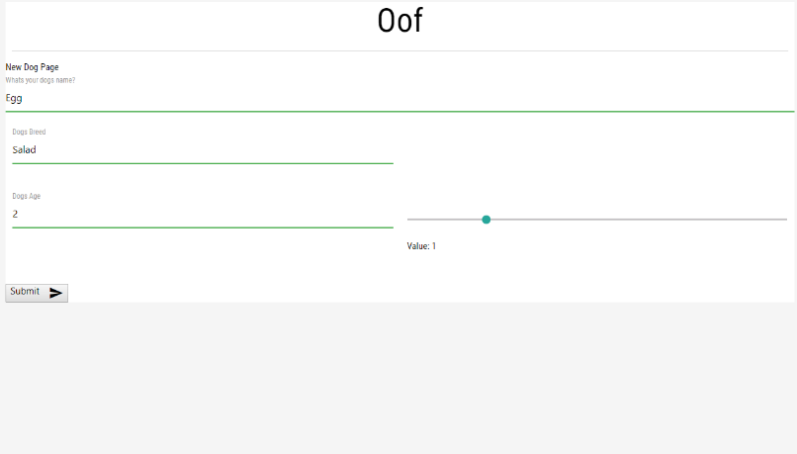

|  |  |  |
| --- | --- | --- |
| Input | Expected Outcome | Actual Outcome |
| Age = 4 | Yes | Yes |
| Age = ewr | No | No |
| Breed = Cauliflower | Yes | Yes |
| Name = Egg | Yes | Yes |
| Friendliness is limited to 1-5 as it is a slider so this does not need testing. It is limited to its boundary cases and cannot fail. |  |  |

Fixes: None needed

Yes. It works

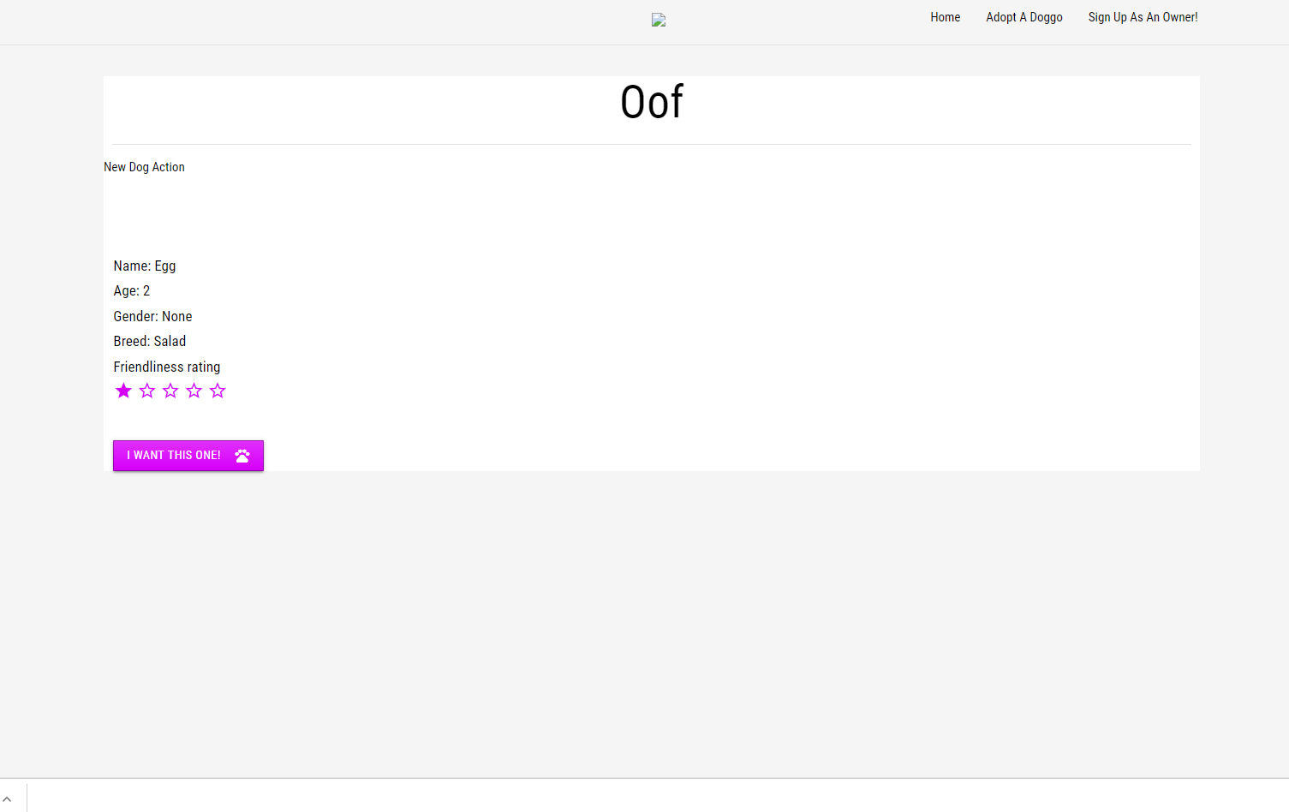

Does it show up on the dog list? / on the showcase page?

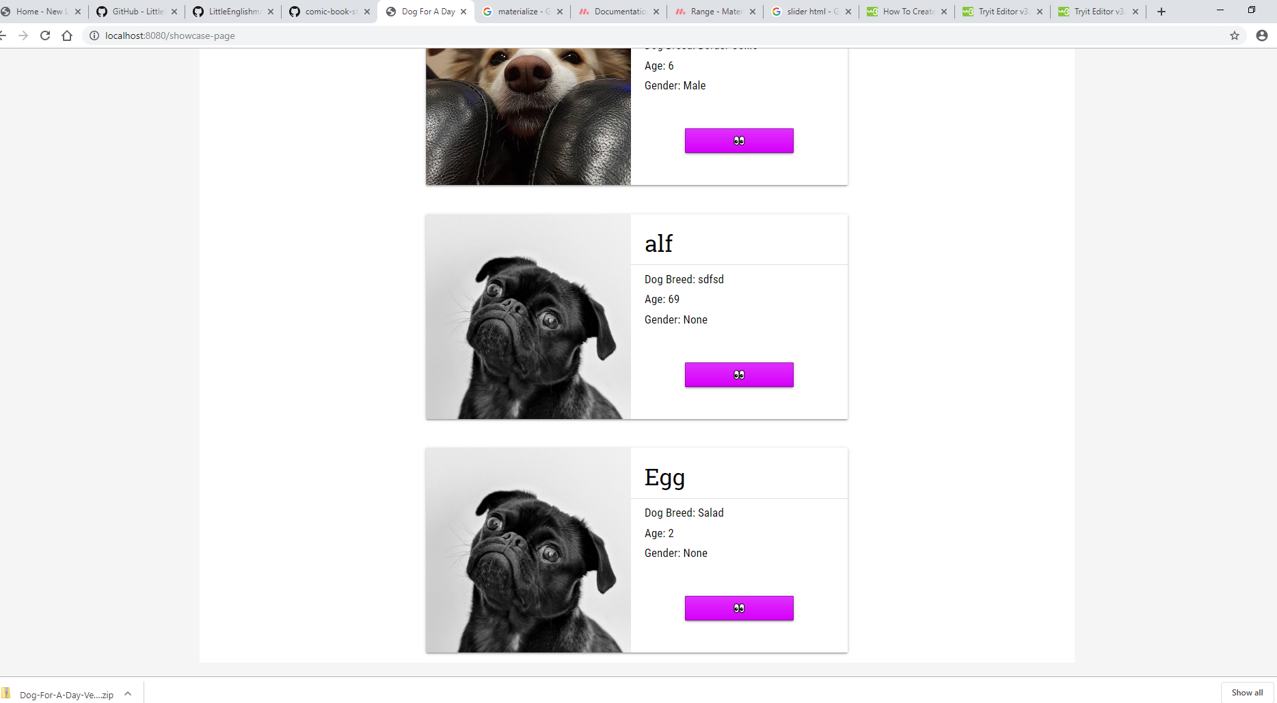

Yes it does. You can see the new dog, named “Egg”

Does it throw errors with any inputs? No, as I am using materialize, it locks the user out form entering the wrong inputs. Name and Breed can be anything the user desires. (These are custom so numbers are allowed). Age is restricted to being a number, no matter how old they are, 0-infinity

This means that I do not need to test cases.

While the friendliness is a slider limited from 0-5, no other inputs are allowed. This stops the user form being able to enter inputs that are outside the desired range so there is no need to test them. Each value works otherwise.

Task 14: Evaluation

This version worked out well and successfully does what it needs to. It maintained the style of the application and added a necessary feature to it that allows the user to add new dogs. This is vital for it to be a successful page as otherwise we would be limited to only renting out the initial test data cases. In the end this version was rather large and worked out very well.